

**ISTE-444 Web Server Development and Administration**

Linux and Bash Practice

# **Instructions**

ICD-10, or the **International** Statistical **Classification** of **Diseases** and Related Health Problems, 10th edition, is the code set used to identify medical diagnoses and procedures for billing, reporting, and research purposes. ICD-10-CM (Clinical Modification) is used for diagnoses and ICD-10-PCS (Procedural Coding System) is used for procedures.  
  
ICD-10 codes are grouped together for billing purposes into Diagnostic Related Groups (DRG). There are different DRG groupers, including MS-DRG, used by CMS (the Centers for Medicare and Medicaid Services) and APR. Each DRG is assigned a relative weight, which roughly indicates how much reimbursement a hospital is owed, relative to other DRGs. I.e., a relative weight of 25 would, in theory, pay 5x as much as a relative weight of 5.

Use the provided ICD-10 data files to answer the following exercises.   
Provide a screenshot or copy/paste your command for each.

# **Questions**

1. Find the total count of lines, in all of the files, that contain the word “fever”, regardless of case.  
     
   
2. Display the unique ICD-10 codes, sorted alphanumerically, for all diseases that contain the word “fever” (again regardless of case). Don’t worry about making them display in columns, but hooray if you do.  
   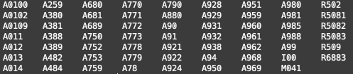  
   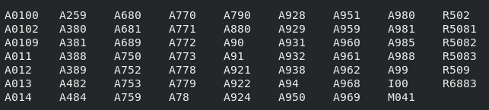
3. Display the list of all files that contain “icd” in the file name, with the most recent years first.   
   Hint: use the find command.

  
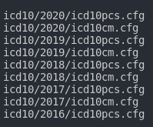

1. In the 2020/cms.cfg file, list the DRGs, DRG descriptions, and relative weights (wt) for all DRGs that have a relative weight greater than 8, sorted by relative weight in descending order. In other words, what are the diagnostic groups that will result in the greatest reimbursement?  
   Hint 1: Use BEGIN { FS = "|" } ; in awk to specify the field separator  
   Hint 2: awk has a substr() function  
   Hint 3: Convert strings to numbers in awk by adding 0  
   Hint 4: You can specify which column sort should sort on  
   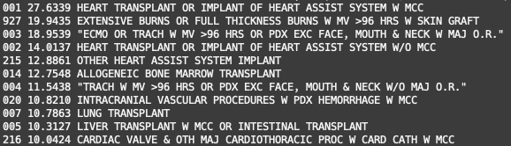  
   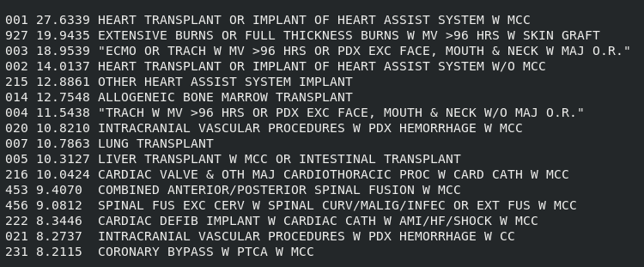
2. Write a Bash script that receives two integer arguments and iterates from the first to the second, displaying how many DRGs have a relative weight greater than each number.  
   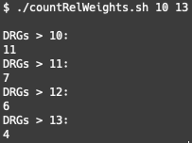 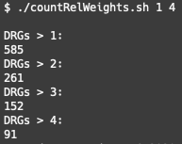  
     
   For bonus, get the count to appear on the same line as its label:  
   